Thomas Ryan 12/06/1925—21/06/1961

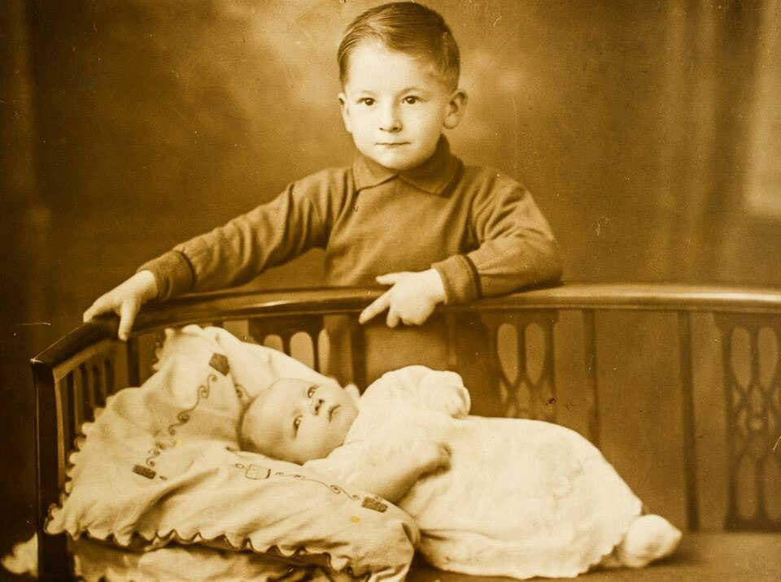
Thomas Ryan was born in Manchester on the 12 June 1925 to Thomas Ryan and Margaret Ryan Nee Nuttall. He grew up in Bickley Street, Moss Side, Manchester with his younger sister Winnifred (Winnie). The house had an outside toilet and opened directly onto the street.

His father Thomas had been injured in the First World War and lived at Broughton House, Manchester coming home to Bickley Street at weekends. Winnie recalled Her father taking young Thomas to football matches at Manchester City in his wheelchair. They sat at the side of the pitch as Thomas senior was disabled.
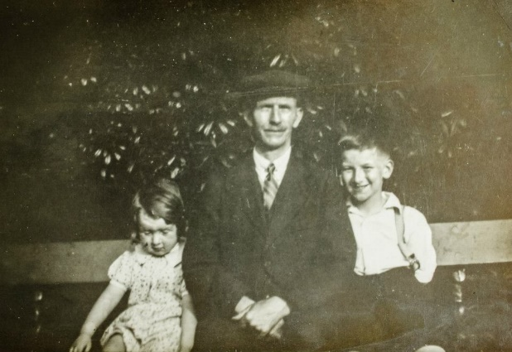

Thomas was very bright and won a scholarship to the local grammar school. He was particularly good at maths getting ‘very good’ in his matriculation report in 1940.
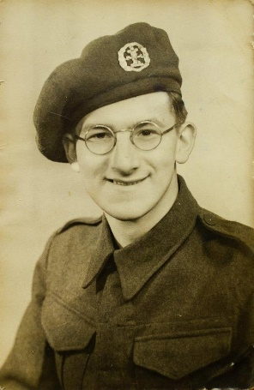
Thomas served in the Second World War in India at one point being in Calcutta. He went on to become a sergeant. He did not see any action but his academic talents were used as office staff.

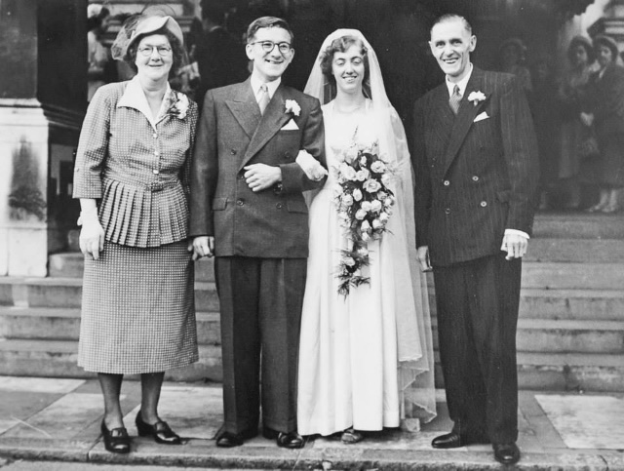
Thomas married Pauline Crowhurst on 14th June 1952 at Brompton Oratory, Kensington. They met at the hostel in Princes Gate where they were both living. They moved to a flat in Clapham where their first child Peter was born in April 1953. Shortly after they moved to St. Mary Cray, Kent where 2 daughters, Margaret and Mary were born. They then moved to Harrow Road, Carshalton, Surrey where their 3rd daughter was born in 1960. Thomas had become a chartered accountant with the admiralty by this time taking his exams through a correspondence course.

On the 21st of June 1961 Thomas travelled to Ipswich on business whilst there he suffered a massive heart attack and died. He was 36 years old.

